Name: D.Madhu varsha

E-Mail: madhuvarsha35@gmail.com

PhoneNo: 7396445916

RollNo: 20NN1A1210

College No: Vignan’s Nirula Institute of Technology and Science for Women.

**Source Code**

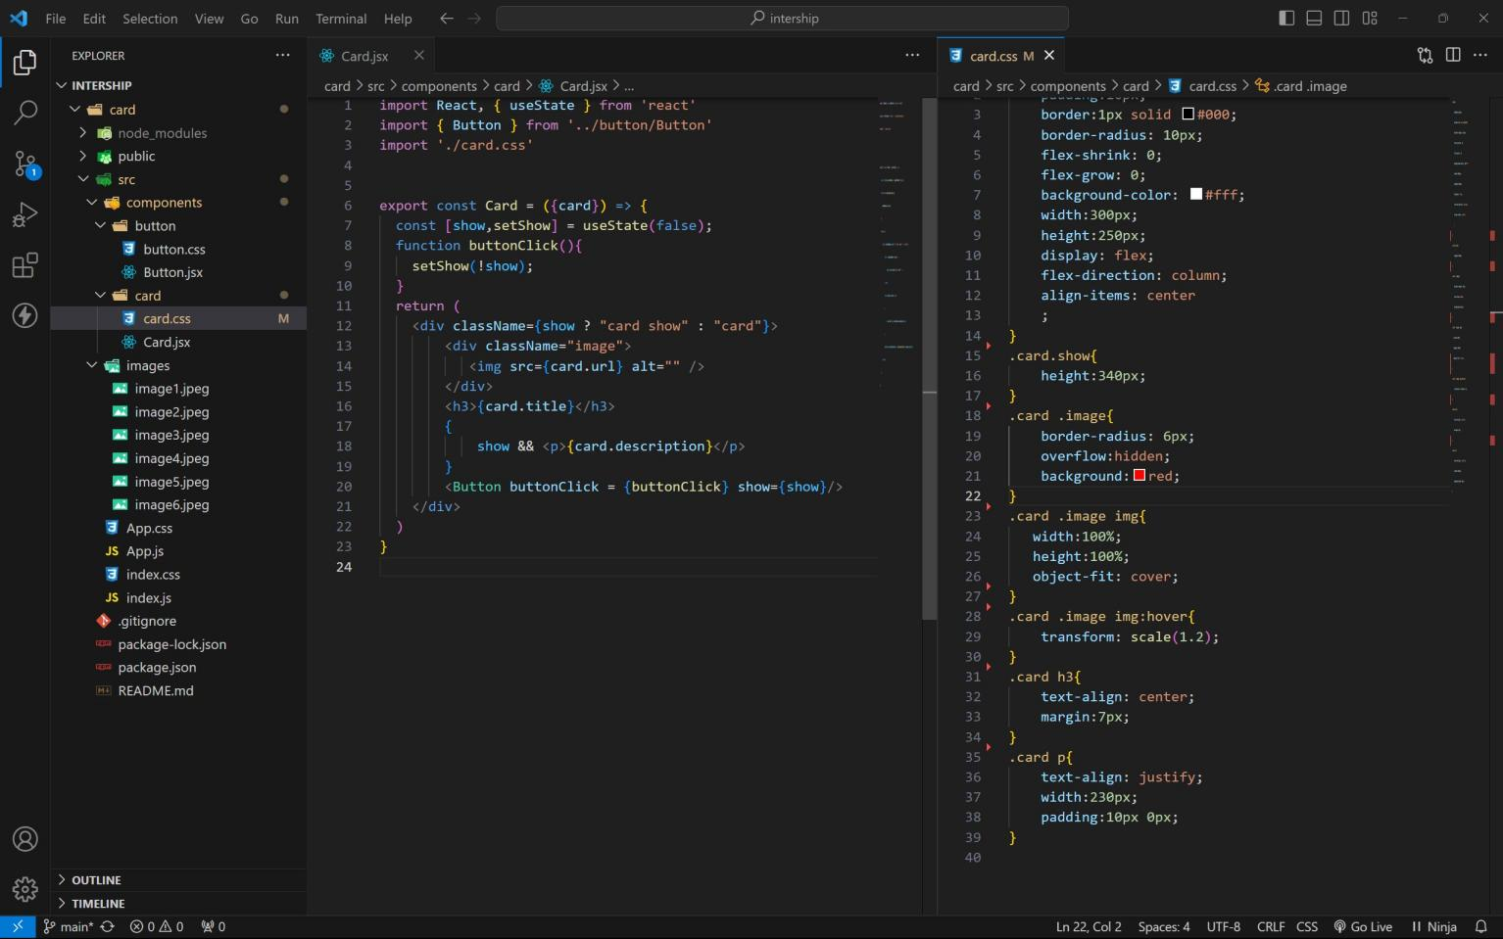Card Component

Button Component:

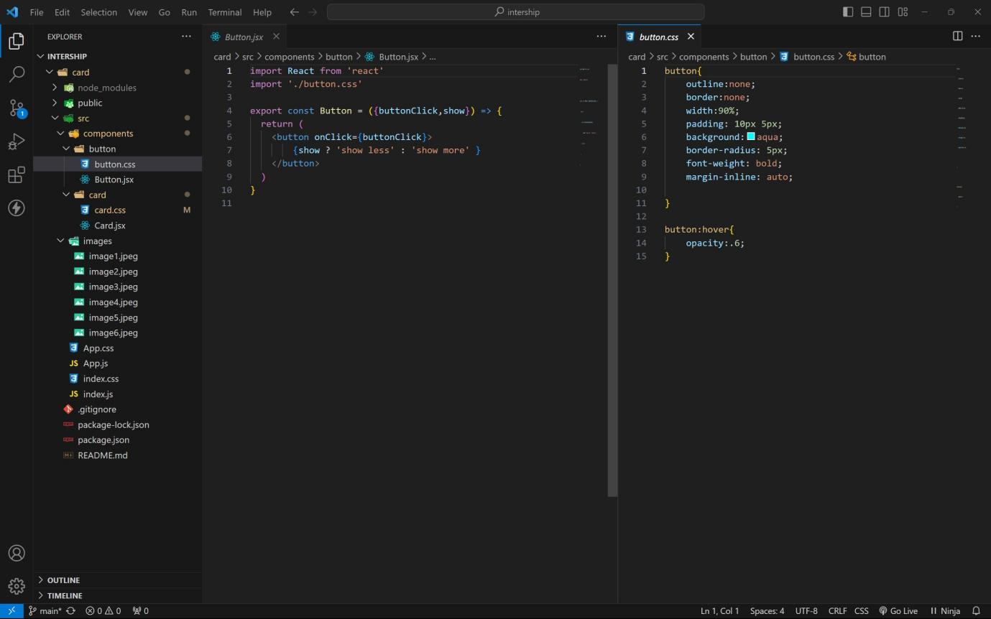

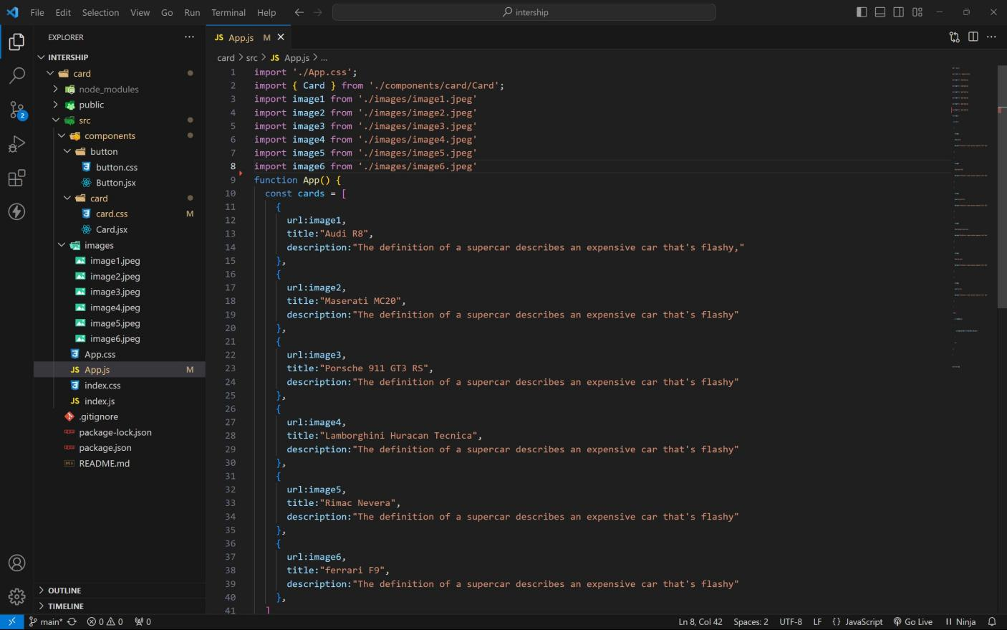App Component:

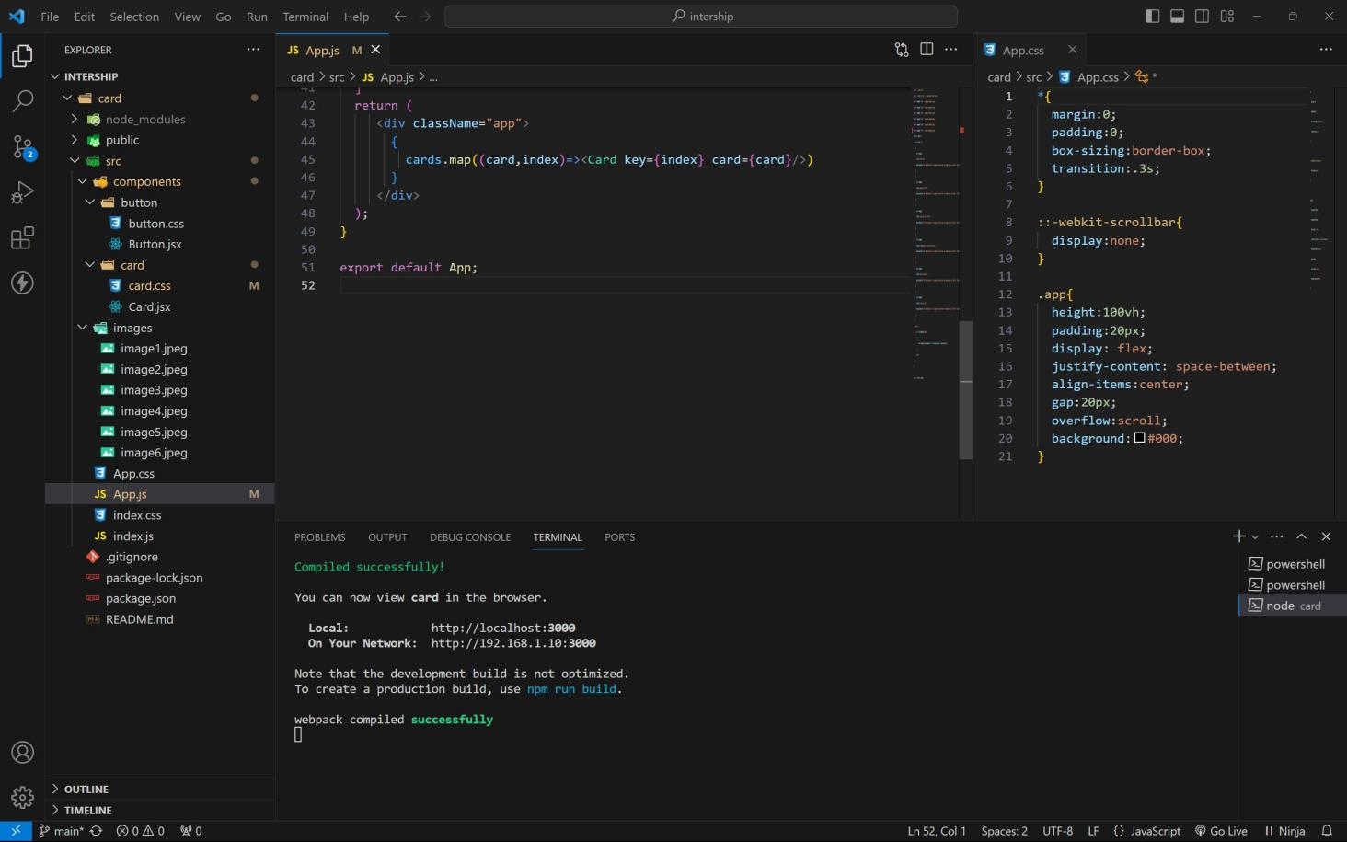

Approach :

1 . Initially take an array of objects like below

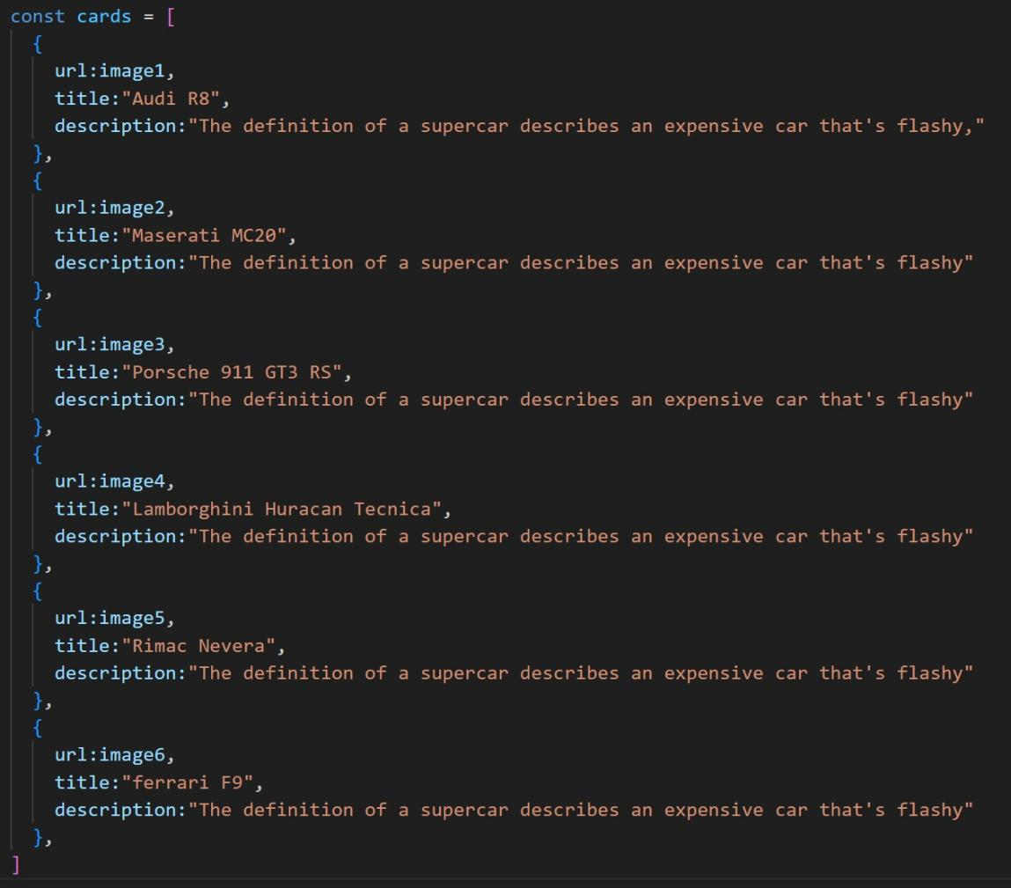

2. Passing this card array to child (card component) of App component by using props;

3. Getting data as argument like {card} in card component.

4. In card component i use one state [show, setShow] to get extra info as description.

5. When we click the button then show becomes true by assigning setShow (!show).

**Output:**

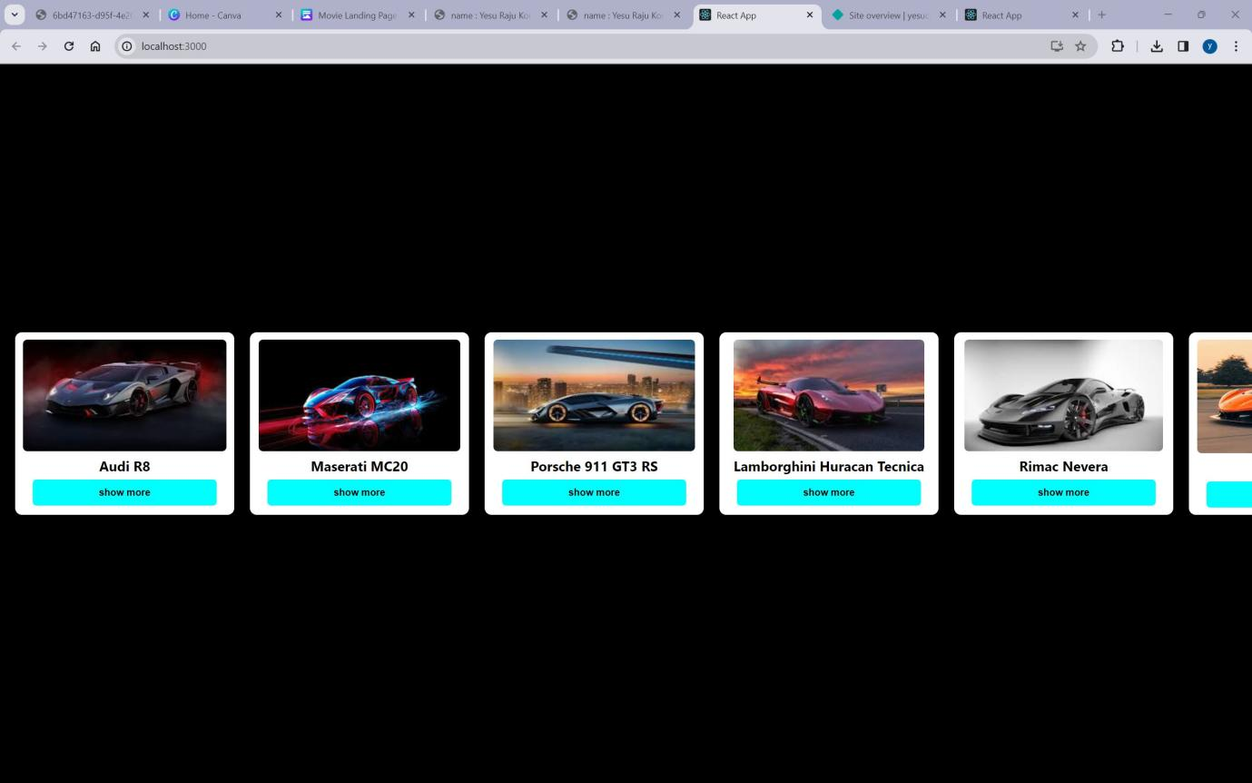

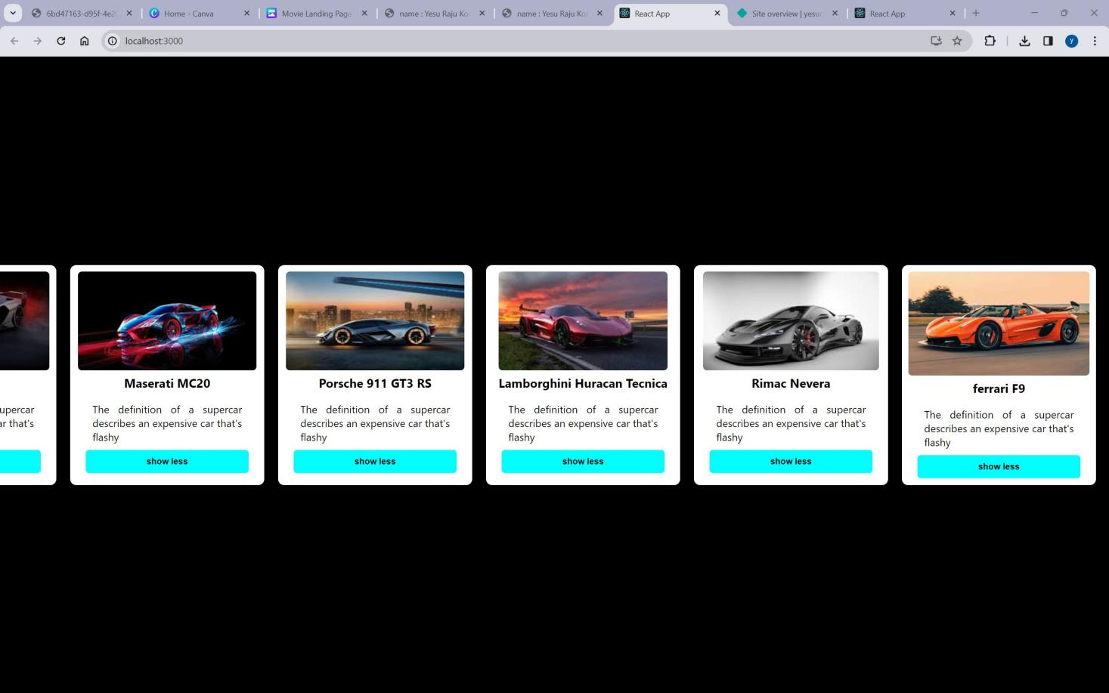After Button Clicks:

